Training for the Cross

Competing from the Holy of Holies
(Ranch Roping, Rodeo and Business)


“Train up a child in the way he should go and when he is old
he will not depart from it.” (Proverbs 22:6)

By: Wade Black

3rd Post “Strongholds”

My entire life I have ridden horses. For the last 24 years I have ridden colts, and for the last 18 years I have either been in training to ride broncs, or training others to ride broncs. The most important thing in riding a horse that could possibly buck with you is learning correct muscle memory. The horse is going to act and your split-second reaction to the horse’s action determines whether your butt stays in the saddle or your head ends up in the dirt. Muscle memory is everything. Often, we make bronc riding too complicated. The bottom line is there are three basic things that a person needs to do to ride broncs. If a person can learn to do these three things successfully, they will have success riding broncs. If you don’t, you will get beat up, probably end up hurt, and more than likely quit because you are tired of getting beat up. These three things are lift, charge, and ride your horse. I will break these down further as the Bible study progresses and we discuss “correct muscle memory” and “tearing down strongholds.” It is important to realize that regardless of what horse you have drawn, what level or circuit you are riding in, what bronc saddle you are riding, or what your particular style is, if you do not do these three things you will not be successful.

There are basically three things that a child of God needs to do, and three things a child needs to know, and it doesn’t matter what church you go to, what Bible version you read, or how you worship God. If you don’t do these three things you will not be successful. It is also important to point out success in the kingdom looks different than success in the world. “And when he had called the people unto him with his disciples also, he said unto them, “Whosoever will come after me, let him deny himself, and take up his cross, and follow me. For whosoever will save his life shall lose it; but whosoever shall lose his life for my sake and the gospel's, the same shall save it. For what shall it profit a man, if he shall gain the whole world, and lose his own soul? Or what shall a man give in exchange for his soul? (Mark 8:34-37)”

Just like it takes a bronc rider his entire bronc riding career to learn how to better “lift on the bronc rein,” “charge to the front end” (setting the feet in the neck), and “ride the horse” (to feel the horse underneath him, get in time and move with the horse, not against the horse); it will take a child of God his entire life to learn these three things. Before I tell you these three things I would like to share with you a little history of how I discovered the three things you need to know and three things you need to do in being a child of God.

Last spring my health was starting to go downhill like it often does during stressful times and has since I was a junior in high school. I was so tired of struggling with health problems, I started to get mad at God. I cried out to God for an answer to why He would not let me just be “healthy” and operate like everyone else. Well, God answered me and basically asked the question, “What does it mean to be healthy?” He began to show me that we are three different parts; body, soul and spirit and in order to be truly “healthy” we must give all three parts of our being what they need to survive. Below I have outlined what our body, soul and spirit needs in order to be healthy.

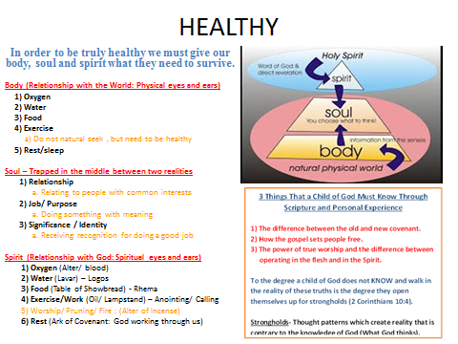

Throughout this Bible study I will continually discuss the different parts of the human body and how we encounter the reality of this world and how we encounter the reality of heaven through Jesus. As you can see in this graph, I have outlined the three different parts to the human body and what they need to be healthy. In answer to my question of “Why can’t I just be ‘healthy’ like everyone else?” the Lord so lovingly showed me that it was not my “body” that was unhealthy it was my “soul.” It is the sickness in my soul that manifests in my body in the form of Chronic Fatigue Syndrome. The sickness that I think at times is in my body is actually in my soul. This sickness has resulted from trying to meet the three needs of my soul (relationships, job/purpose, and identity/significance) in my relationship with the world through my body, instead of RESTING in my relationship with God through the Spirit. After struggling with sickness for 18 years, my prayer for this Bible study is to help prevent young kids starting out in their relationship with the Lord from sickness in the body and in the soul (mind, will, and emotions).

During this fall we will be focusing on “the war over reality” and tearing down strongholds. As a born again child of God we are in battle. However, our battle is not with flesh and blood, it is with principalities and power of darkness in the heavenly places (Ephesians 6:12). Our battle, our war that we fight is actually learning to REST in the finished work of the Cross. I have trained intensively in wrestling, football, track, riding broncs, and even managing my own horse training business. However, the most intensive training and the hardest thing I am convinced in this life is learning to REST in the finish work of the Cross and learning to work in this world out of this rest. Learning to work hard in the body and having rest in the soul. The scripture below will be a key concept throughout this entire Bible study and has been an absolute key to my healing in body, soul and spirit.

“There remains therefore a rest to the people of God. For he that is entered into his rest, he also hath ceased from his own works, as God did from his. Let us labor therefore to enter into that rest, lest any man fall after the same example of unbelief. For the word of God is quick, and powerful, and sharper than any two-edged sword, piercing even to the dividing asunder of soul and spirit, and of the joints and marrow, and is a discerner of the thoughts and intents of the heart” (Hebrews 4:9-12).

This will be a key concept over the next three terms, “How do you LABOR to enter REST?” I will be going over the below Tabernacle graph and many others as the Bible study progresses. We will break down the pattern of the tabernacle God gave to Moses and how it outlines our spiritual journey to wholeness (gate, alter, laver, lampstand, alter of incense, ark of the covenant) using horse parables.

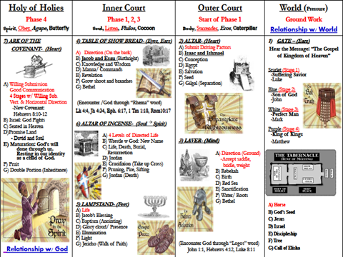

The title of this Bible study is “Gideon’s 300” and the focus is “Training up a child in the way that they should go so that when they are old they will not depart from it.” As a parent the Lord showed me that there are three things that my kids must know through scripture and through personal experience. The Lord then showed me the degree that my kids do not know and walk in the reality of these truths is the degree that they open themselves up for strongholds. Strongholds are thought patterns that create a reality that is contrary to the knowledge of God (what God thinks). Whether a person is learning to ride broncs, train a wild horse, to rope or be disciple of Christ, muscle memory is everything and the focus of a good coach is not letting incorrect muscle memory (strongholds) get started. In all of my classes I put together a syllabus and on the syllabus I have “course outcomes.” The course outcomes for this Bible study are:
It is my prayer that students will know through scripture and personal experience:
1) The difference between the old and new covenant.
2) How the gospel sets people free.
3) The power of true worship and the difference between operating in the flesh and in the spirit.

It is my prayer that students will also know through scripture and personal experience:
1) How to love God (relate to the Father as a child of God, not as an orphan).
2) How to love people (reflect the love of the Father to those around you).
3) Do what God has called you to do (get an assignment from the Lord and begin taking steps of obedience to fulfill the assignment).

Just like a person needs to understand how to lift and charge to “ride the horse” not fully understanding number 1 and number 3 in the first set of course outcomes has taken me a lot of years to understand number 2, “How the gospel sets people free.” Also just like riding broncs, the three things that a child of God must do is also a daily struggle. Some days you draw the easy hoppers, get tapped off and things are fun and easy, and other days you draw into the eliminator pen, get the tar beat out of you and it makes you question whether you want to keep entering. My prayer for this Bible study is that you will learn some tips that will help you with your horsemanship, stockmanship, roping, and rodeo skills, but more importantly that through these parables you will have on-going encounters with Jesus and that you will experience the fullness of the gospel. The gospel not only has the power to save your soul for eternity when you die, but to save your body and soul (mind, will and emotions) on a daily basis.

As you watch the rides in this clip realize that they did not intend on getting bucked off when they called for the horse and opened the gate. They had a perfect bronc ride pictured in their mind and a solid game plan of: lifting, charging, and riding their horse. However, as anyone that has ever ridden rough stock can tell you, although you may have it all planned one way to please the judge, sometimes you get drilled before you even know what happened. As young men and women starting in your relationship with the Lord, you will soon come to find out it is the same way. However, my idea of a warrior, whether in rough stock or being a disciple of Christ, is someone that does not quit after getting bucked off. Instead they go back into training (body, soul and spirit) to learn how to better lift, charge, and ride their horse (rodeo), or how to better love God, love people, and finish their job (child of God). After every one of these buck offs the cowboy had a choice to be influenced by the pain and disappointment of getting bucked off, or to shake it off and “press on to the mark of the prize”.
“I press toward the mark for the prize of the high calling of God in Christ Jesus. (Phillipians 3:14)”

Now let’s pull our hats down and start the process of learning how to put on the “full armor of God.” To learn how to lift, charge, ride our horse and press on to the mark for the prize of the high calling in Christ Jesus (Philippians 3:14).

https://www.youtube.com/watch?v=qkm4l0okXBY

