Training for the Cross

Competing from the Holy of Holies
(Ranch Roping, Rodeo and Business)

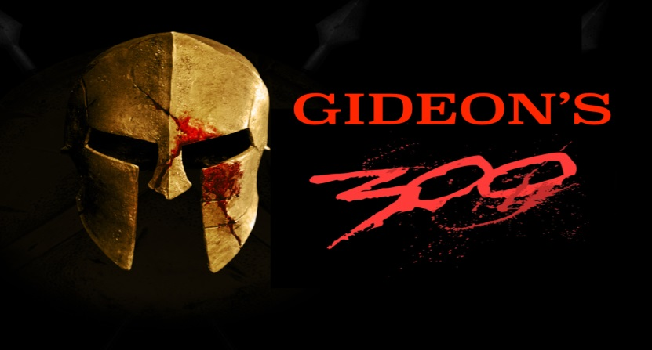
“Tra*in up a child in the way he should go and when he is old
he will not depart from it.” (Proverbs 22:6)

By: Wade Black

7th Post – King Xerces
“The Spirit of Mammon”

As mentioned in the previous post I would like to share what I believe to be America’s Xerces. In the beginning scene of 300, there was a Persian messenger that shows up on the Spartan steps with “heads of conquered kings,” and threatens the Spartan people with slavery and death. In the clip below that I showed earlier, King Leonidas was not about to surrender to anything that would eventually lead his people to bondage and death. King Leonidas was a King, a King willing to defend his people and die protecting the Spartan culture.

300 This Is Sparta:
https://www.youtube.com/watch?v=514IEcgz1Q8

As young children of God wanting to learn how to compete from the Holy of Holies (relationship with God) it is important that you are aware of what I believe to be your King Xerces. At some point every business owner will have the same lies from the enemy show up on the steps of your heart and make the same threats that the Persian messenger made. Before I go much further I would like to show a clip explaining just exactly what King Xerces is to business owners, he shows up in the form of the “Spirit of Mammon.” Below is a clip from Robert Morris explaining what the “Spirit of Mammon” is and what lies he will try to tell you.

Breaking the Spirit of Mammon:
https://www.youtube.com/watch?v=RD32mdpO3Ng

As Morris explained “mammon” is so much more than just money. The “spirit of mammon” was a Babylonian spirit that goes all the way back to the tower of Babel.

“And they said, Go to, let us build us a city and a tower, whose top may reach unto heaven; and let us make us a name, lest we be scattered abroad upon the face of the whole earth. And the LORD came down to see the city and the tower, which the children of men built. And the LORD said, Behold, the people is one, and they have all one language; and this they begin to do: and now nothing will be restrained from them, which they have imagined to do. Go to, let us go down, and there confound their language, that they may not understand one another's speech. So the LORD scattered them abroad from thence upon the face of all the earth: and they left off to build the city. Therefore is the name of it called Babel (Greek- Confusion); because the LORD did there confound the language of all the earth: and from thence did the LORD scatter them abroad upon the face of all the earth” (Genesis 11:4-9).

The Lord showed me this scripture last year around the time that I was having my college kids put together a business plan for their business and marketing class. One of the things that I have my students do is come up with a business name and try to decide what they are “known” for. I ask them the question, “When people say your name, what will it be associated with?” Some students plan on starting colts, some making performance horses, or trail/kid horses. Some plan on running cows and using horses to supplement their ranching business, and some plan on have a boarding facility or giving lessons, etc. etc. etc. Most of my students going through this Bible study are getting ready to produce something in the Ag industry. Even if it is being successful in rodeo, or horse showing focused on producing solid runs, or rides that produce checks. However, as a child of God it is imperative that you do not lose your name/identity in heaven. As I have mentioned several times throughout this Bible study, we are three different parts: body (world-consciousness), soul (self-consciousness), and spirit (God-consciousness).

We know that we have begun to “serve” mammon when our soul (self-consciousness: mind, will, emotions) has a begun to be more influenced by what we have experienced in our relationship with the world through our body, than what we have experienced in our relationship with God through the Spirit. We are serving mammon, when our business is focused solely on gaining money or glory for ourselves and has little or nothing to do with the gospel of the kingdom of heaven. “No servant can serve two masters: for either he will hate the one, and love the other; or else he will hold to the one, and despise the other. Ye cannot serve God and mammon” (Luke 16:13). As Morris pointed out, you cannot serve both God and mammon. The spirit of Mammon comes from the tower of Babel (confusion) where they wanted to “make a name for themselves.” Here are some very simple practical ways to determine if you have begun to “serve” mammon.

1) Identity – Your identity is influenced more by your relationship with the world
through your body than your relationship with God through the Spirit.

2) Tithes and Offerings – Not tithing, or feeling resentment about tithing.

3) Confusion – As Morris pointed out “mammon” comes from the tower of “babel” and
Babel means “confusion.” Serving mammon scatters your thoughts (not clear where you are going and causes fear and anxiety about the future) and causes division
especially between man and wife.

5) What you are working for – Once we begin to “serve mammon” all our
decisions are focused on gaining more money, or glory for ourselves and has little or nothing to do with finishing the work God has called you to do for the Kingdom
(1 Peter 4:9-11, Ephesians 4:11-13, 1 Corinthians 12, Romans 12:1-8).

6) Have a low opinion of God – “You will either hate the one and love the other or
hold to the one and despise the other.” Despise comes from the Greek word meaning to “disesteem” and disesteem means: Have a low esteem or regard (noun), have a low opinion of (verb). Although we may go to church on Sunday our soul is not influenced by the Spirit of God throughout the week and this “separation”
from the Holy Spirit will lead to a “low opinion of God.” Unlike a son whose soul is in
relationship with the Father and “magnifies” to the world the “goodness of their God.”

7) Works of the Flesh – “This I say then, Walk in the Spirit, and ye shall not fulfil
the lust of the flesh” (Galatians 5:16). When we make a choice to “serve” the “spirit of mammon” we make a choice to not serve the “Spirit of God.” For me the best judge as to who I am serving in my business, is the fruit that I produce throughout the day while working in my business.

8) Sickness – This has always been my best guide as to who I am serving. As I have
said many times throughout this Bible study, the Lord has given me a choice every day. I can either live and work on the right side of the graph with, “rest, relationship,
and righteousness,” or on the left side of the graph with “fear, sin, and sickness.”

I am sure that there are probably many more signs of serving mammon. These were just some of the biggest ones that I have noticed in my life. Remember as a child of God our purpose is reflecting the love of the Father wherever we have been placed. To do that we must have a good prayer closet, and be able to close the door to what our soul has begun to be identified through our body (either good or bad), so we can open the door to heaven through the Spirit to receive perspective on our true identity and purpose through our business.

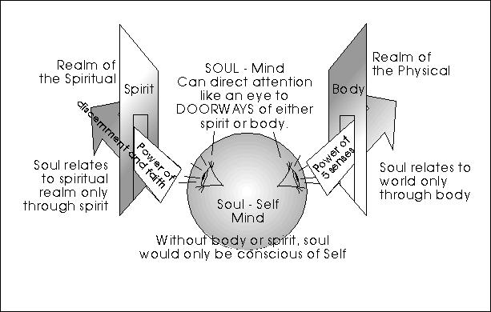

The primary battle is to maintain “our prayer closet,” and I am convinced it is the hardest thing in this life. Just like it was always a battle making sure you got a good mark out at the start of a bronc ride, starting the day out of a productive prayer closet is every bit as tough. As you can see in the next clip after Leonidas takes a stand against King Xerces and will not surrender, Xerces tries to “reason” with Leonidas. I cannot even begin to tell you how many times the enemy has done this to me. As a born-again child of God, you will definitely come to find out that whenever you try to take a stand as a child of God (get up the morning to read your Bible, be committed to going to church, going to a youth group/Bible study, especially starting the day praying with your spouse), the enemy will do everything in his power to prevent this from happening, and after you begin to have victory he will begin to “rub your shoulders.”

Leonidas Vs. Xerxes:
https://www.youtube.com/watch?v=zvILGIIVsMU

There are several things that ready jumped out at me in this this clip, and to be honest it kind of creeped me out how many times I have listened to “mammon” when he rubbed my shoulders. To start out let’s look at Xerces’ first line:

King Xerces: “Come Leonidas, let us reason.”

This will be where the enemy tries to take us every time. Bottom line, as a child of God you will need to decide if you will be a disciple of Christ with a Kingdom way of thinking, or a disciple of Herod with a political way of thinking, or a disciple of the Pharisees with a religious way of thinking. Do you want to live as a son on the right side of the graph with “rest, relationship, and righteousness” or be an orphan on the left side of the graph with, “fear, sin, and sickness?”

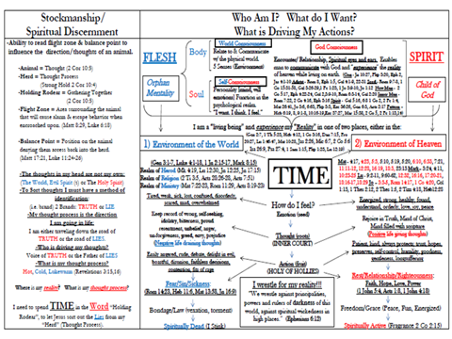

Remember that sickness can either be in the body or the soul (mind, will, emotions). However, after salvation if we chose to pursue a relationship with the world to find our identity, instead of God, I guarantee we will have some form of sickness.

“And he charged them, saying, “Take heed, beware of the leaven of the Pharisees, and of the leaven of Herod.” And they reasoned among themselves, saying, “It is because we have no bread. And when Jesus knew it, he said unto them, “Why reason, because you have no bread? Perceive you not yet, neither understand? Have ye your heart yet hardened? Having eyes, see you not? And having ears, hear you not? And do ye not remember? When I broke the five loaves among five thousand, how many baskets full of fragments took you up? They say unto him, Twelve. And when the seven among four thousand, how many baskets full of fragments took you up? And they said, Seven. And he said unto them, “How is it that you do not understand” (Mark 8:15-21)?

“Repentance” means to “think differently.” After the disciples saw the miracles of provision He expected them to “repent” and think like a son. However, they still had a worldly way of thinking and this was tied to their “hard heart” where they could not “see” or “hear” what Jesus was doing. Although, they were in God’s presence they could not encounter the works that Jesus wanted to perform in and through them because of their worldly way of thinking (Herod, Pharisee). After salvation, it is imperative that you learn to “think differently.” This is the battle that every newborn believer must enter. Just like King Leonidas you will have a choice. Will you “reason” with the enemy and think like an orphan, or will you listen to what the Holy Spirit is saying through scripture in any and every situation and think like a son. The word “reason” and “imagination” is the same word in the Greek “Logismos.” As I said earlier, this is the battle, and this is the war we are in.

“For though we walk in the flesh, we do not war after the flesh: (For the weapons of our warfare are not carnal, but mighty through God to the pulling down of strong holds ;) Casting down imaginations, and every high thing that exalts itself against the knowledge of God, and bringing into captivity every thought to the obedience of Christ; And having in a readiness to revenge all disobedience, when your obedience is fulfilled. Do ye look on things after the outward appearance? If any man trust to himself that he is Christ's, let him of himself think this again, that, as he is Christ's, even so are we Christ's. For though I should boast somewhat more of our authority (Greek- Exousia), which the Lord has given us for edification, and not for your destruction, I should not be ashamed: That I may not seem as if I would terrify you by letters” (2 Corinthians 10:3-9).

To “pull down strongholds” we must learn to think like a son, and it is so important that you surround yourselves with other sons. As I said earlier, although a Spartan may had been born a Spartan and had Spartan blood running through his veins, it was the Spartan culture that produced warriors. This is the prayer of this Bible study: to create a culture of cowboys who will take a stand against King Xerces and will defend their kids from being infecting by a worldly way of thinking that will eventually lead to “bondage and death.”

King Xerces: “There is much our cultures should share”

Just as King Leonidas was not about to mix the Persian culture with Spartan Culture, Jesus was adamant that their disciples did not mix cultures as well. Jesus did not want the disciples to mix a kingdom way of thinking with a “Herod” way of thinking or “Pharisee” way of thinking. Just as King Leonidas knew that if they surrendered to Xerces, he would lead them to bondage and death, Jesus knew that surrendering to the wrong way of thinking would lead them to bondage and death as well.

This line in the above scripture is huge. “Authority which the Lord has given us for edification and not for your destruction.” This scripture is so important in realizing what we have been given as children of God. As a born-again child of God, we have been given authority (Exousia). I will explain later the importance of walking in Authority (Exousia). However, I will point out right here that we have been given “Exousia” for “edification” and not for “destruction.” “But as many as received him, to them gave He power (Exousia) to become the sons of God, even to them that believe on his name” (John 1:12). In this scripture, the translators used the word “power” but the Greek word is actually “Exousia” which means “Authority.” I will explain the significance of these two words in the next post and the impact it has had on my health the last 16 years. I will just point out now that we have been given “Authority” as sons of God and we have been given this for “edification” and not “destruction.” In every situation we encounter, we will either allow “strongholds” into our life which will cause us to lose our authority as a son and speak words of “destruction” (tearing down), or we can repent “think differently” (like a son) and speak words of edification (building up), to ourselves and those around us.

As I said earlier a “Stronghold” is a way of thinking that is not how God thinks. After you have accepted Jesus into your heart and you have the reality of Heaven living on the inside of you (Luke 17:20-21), we have a choice in any and every situation. The question is, “Will we operate as a son with a “Kingdom Mentality” (See your heavenly Father and people around you through the eyes of Jesus), or an Orphan with a “Herod Mentality” (see God and people around you through a political lens), or “Pharisee Mentality” (see God and people around you through a religious lens)?”

It is important as a child of God that we know the difference between “Power” (Greek- Dunamis) and “Authority” (Greek- Exousia). Power comes from the Greek word “Dunamis” and is where we get the word dynamite. We do not experience any “Dunamis/power” from God when we are operating in the realm of the Herod or the realm of Pharisee. This is why Jesus warned His disciples not to “reason” from this place. However, once we die to those to realms and begin to experience “exousia/authority” as a Child of God (right side of the graph), it is from this place of rest that “Dunamis/power” will go through us to touch others. This is what happened to Jesus with the woman that touched Him. “And Jesus said, “Somebody has touched me: for I perceive that virtue (Dunamis) is gone out of me” (Luke 8:46). Jesus was not seeking “dunamis/power” He was walking in the “authority/exousia” of a Son and it was from this place of rest that “power/dunamis” went through Him. This is what Jesus said His disciples would receive on the day of Pentecost, (dunamis/power). “But ye shall receive power (dunamis), after that the Holy Ghost is come upon you: and ye shall be witnesses unto me both in Jerusalem, and in all Judaea, and in Samaria, and unto the uttermost part of the earth” (Acts 1:8).

Hopefully through this post you have learned the importance of not being influenced by a “Herod Mentality,” or a “Pharisee Mentality.” However, it is also very important that as you surrender to God and His “power, dunamis” comes on you for the “edification of the body of Christ,” that you begin to operate in the spiritual gifts and talents He has given you as part of your inheritance as a child of God. It is important that you do not begin to seek your identity in “Ministry” and begin to see the world only through your spiritual gift lens and what He has called you to do. An orphan in Ministry (focused more on sharing your relationship with God instead of having a relationship with God) is even more dangerous and can be more destructive than a “Herod” or “Pharisee” way of thinking.

One of the best ways to determine which mind sets you have been influenced by is to ask yourself, “What is the problem with the world and what is the solution?” Someone with a Herod mindset will point out political problems and their political party having all the solutions. Someone with a Religious way of thinking will point out problems with the world and other churches and how joining their church is the solution. Someone with a ministry mindset will see problems through their spiritual gift lens and how their ministry (or someone like theirs) has all the answers. However, a Son operating from Heaven (Holy of Holies) does not try to divide, or segregate the Kingdom of Heaven (Matthew 12:25-28). Someone with a Kingdom mindset sees all the problems with the world come from ORPHANS and people not KNOWING the LOVE of the Father and LIVING in RELATIONSHIP with Him. Over the last 16 years it has been my experience that any one of these ways of thinking (left side of graph) will cause us to lose our “Exousia,” or authority as a child of God, and for me results in “fear, sin, and sickness.”

King Xerces: “Yours is a fascinating tribe. Even now you are defiant on the brink of annihilation. In the presence of a God it is not wise to stand against me. Imagine what terrible fate awaits my enemies when I would gladly kill and have my own men for victory.”
King Leonidas: “And I would die for any one of mine.”
As young men and women beginning to put together your business plans and beginning to make plans to enter the world to start your Ag businesses, I think it is very important to make a choice early on who you will serve. Scripture is VERY clear, you cannot serve both God and mammon (Matthew 6:24, Luke 16:13). Do you want to serve the King who wants to lead you to bondage and death? Or the King that gave his life so that you could have life more abundantly in a relationship with Him?
“The thief cometh not, but for to steal, and to kill, and to destroy: I am come that they might have life, and that they might have it more abundantly. I am the good shepherd: the good shepherd giveth his life for the sheep” (John 10:10-11).

King Leonidas: “You have many slaves, Xerces, but few warriors.”
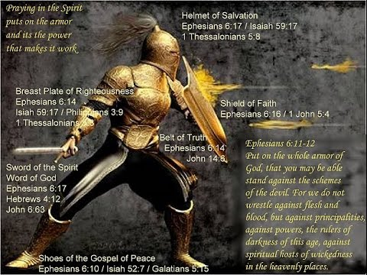
Hopefully this Bible study will help stir up a culture of cowboys who enjoy the process of learning how to practice putting on their spiritual armor as much as they do practicing their horsemanship, stockmanship, roping, and rodeo skills.
King Xerces: “It is not the whips that they fear. It is my divine power. But I am a generous God. I will make you rich beyond all measure. I will make you a warlord of all Greece. You will carry my battle standard to the heart of Europa. Your Athenian rivals will kneel at your feet, if you will but kneel at mine.”
Hopefully this picture of King Xerces rubbing King Leonida’s shoulders and the stories that Robert Morris shared will be a creepy picture of what awaits you in the temptations of who you will serve.

“Now therefore fear the LORD, and serve him in sincerity and in truth: and put away the gods which your fathers served on the other side of the flood, and in Egypt; and serve you the LORD. And if it seems evil unto you to serve the LORD, choose you this day who you will serve; whether the gods which your fathers served that were on the other side of the flood, or the gods of the Amorites, in whose land you dwell: but as for me and my house, we will serve the LORD” (Joshua 24:14-15).

This is the prayer of this Bible study to bring together people that have made a choice to not surrender to King Xerces (Spirit of Mammon) and are willing to follow King Leonidas to the Hot Gates and are willing to take a stand at the great battle of Thermopylae. This will be the discussion for the next post. As young and old Spartans (children of God), what is our battle of Thermopylae? I will give you a hint. It is not just about going to church on Sunday it is about saying, “As for ME and MY HOUSE, WE WILL SERVE THE LORD!!!!”
https://www.youtube.com/watch?v=v_8HYyPEZXM

